HISTORY OF FOOTBALL
PART SIX

CONTACT DETAILS

BRANCH CHAIRMAN & SECRETARY
Mr Dave Brown
25 Charlton Road
Crownhill

Plymouth
Devon
PL6 5EG
Home  01752 219472
Mobile  07973 629717
Email: dave.brown@u-reds.com
Web: www.u-reds.com
Web1: www.forestsupportersclub.com

BRANCH TREASURER
Mr Bryan Smith
2 Town Mead
Oakford
Tiverton
Devon
EX16 9EW
Home  01398 351596
Email: nfsc.sw-m5.treasurer@u-reds.com

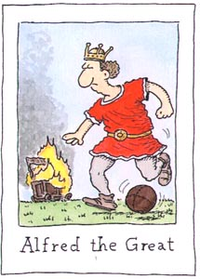

Alfred the Great
Stalwart Wessex wing half and captain whose attempts to branch out into match catering ended in disaster when his burger stall caught fire.

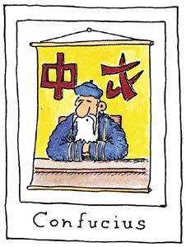

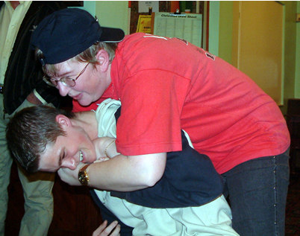

14

Confucius
Revered Chinese football pundit. Intensely boring and predictable. Confucius say: "You'll never win anything with young children or old women." And you have to say he was spot on there.


“Heike gets to grips with young Kev ‘Bronze
Balls’ Durrant whilst whispering ‘sweet nothing’
into his lug hole”
Cheers Dave

